H.T No
Regulations:
A22

Sreenidhi Institute of Science and Technology
(An Autonomous Institution)
Code No:9HC14 Date: 06-September-2024 (FN)

B.Tech II-Year I- Semester External Examination, September -2024 (Supplementary)
COMPLEX VARIABLES AND TRANSFORM TECHNIQUES (EEE and ECE)

Time: 3 Hours Max.Marks:60

Note: a) No additional answer sheets will be provided.
b) All sub-parts of a question must be answered at one place only, otherwise it will not be valued.
c) Missing data can be assumed suitably.
Bloom's Cognitive Levels of Learning (BCLL)

Remember | L1 | Apply | L3 | Evaluate | L5
Understand | L2 | Analyze | L4 | Create | L6

Part - A Max.Marks: 6x2=12

Answer all QUESTIONS, EACH QUESTION CARRIES 2 MARKS.

 |  | BCLL | CO(s) | Marks
1 | Find b such that 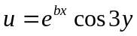 is harmonic function | L2 | CO1 | [2M]
2 | State Cauchy’s Residue theorem | L1 | CO2 | [2M]
3 | Find the fixed points of the transformation | L2 | CO3 | [2M]
4 | State first shifting theorem of Laplace transform. | L1 | CO4 | [2M]
5 | Define Unit Step Function | L1 | CO5 | [2M]
6 | State Change of Scale theorem in Z-transform | L2 | CO6 | [2M]

Part – B Max.Marks: 6x8=48
ANSWER ALL QUESTIONS. EACH QUESTION CARRIES 8 MARKS.

 |  | BCLL | CO(s) | Marks
7. | Determine the value of p such that the function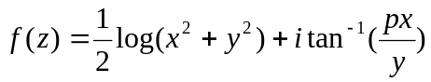 is analytic. | L3 | CO1 | [8M]
 | OR
8 | Find an analytic function f(z) whose real part is u=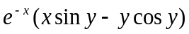 | L4 | CO1 | [8M]
9. | If F(a) = 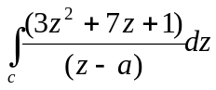 where C is the circle 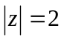then  find the values of the F(1), F(3) , F′(1-i) and F″(1-i). | L4 | CO2 | [8M]
 | OR
10 | Evaluate where using Residue theorem. | L5 | CO2 | [8M]
11. | Find the Bilinear Transformation which maps the points  (,i,0) to (-1,-i,1) respectively. | L4 | CO3 | [8M]
 | OR
12 | Show that the transformation maps the real axis in the z-plane into the unit circle in the w-plane. | L4 | CO3 | [8M]
13. | Find𝐿{𝑒^{3𝑡}𝑠𝑖𝑛²𝑡} | L3 | CO4 | [8M]
 | OR
14 | Evaluate 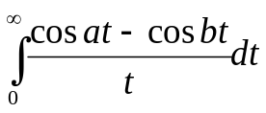 | L4 | CO4 | [8M]
15 | Using convolution theorem find the inverse Laplace transform of | L4 | CO5 | [8M]
 | OR
16 | Using Laplace transform, solve given that | L5 | CO5 | [8M]
17 | Using Convolution Theorem, find the inverse Z-transform of 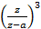. Deduce for 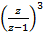 | L4 | CO6 | [8M]
 | OR
18 | Using Z-transform,Solve  with | L5 | CO6 | [8M]

-- 00 -- 00 –

